HERStory: Making Invisible Women Visible
Research notes

Group Number and Researcher Name: Team 4- Ruth Spindlow

Name of Research Focus: Sarah Smithson.
Date of Birth: 1845. | Date of Death: 1928.

Main Reason to Research: The localised impact the academic women of York had on the wider move towards Women’s suffrage.

Are there any other connections to key geographical locations or people?

Joseph Rowntree, Ann Swaine, Petergate, Heworth, Sheriff Hutton, Kirkbymoorside, Clifton.

Key Words: Liberalism, Suffrage, Women’s Liberal Associations, Higher Education.
What have you found out?
[Summary of your research]
- Sarah Smithson was born Sarah Kay in 1845. Her father was a magistrate/ member of the local council and her mother didn't work. In the 1851 Census, Sarah is 6 years old, and living at the family home in Nawton, West of Kirkbymoorside. The family appears very wealthy, they have 5 servants including a groom, a dairymaid, a nurse, a cook and a housemaid. (figure 1.)
- By the 1861 census, Sarah had already left the family home. She is boarding at a school located in “Clifton.” All the students recorded are girls, and the school is run by the Husband sisters. (figure 2.)
- Sarah went on to marry Edward Smithson of St. Paul’s district of York on August 4th 1869, in Sheriff Hutton. Edward was a solicitor, living in York, and 26 years old, a year older than Sarah. (figure 3.)
- 12 years later the 1881 census stated that Edward and Sarah were lodgers for a widow Jane Owston, on Petergate, in York. At this point it becomes clear the couple were living without children, focusing on their respective careers. (figure 4.)
- It was around this time that Sarah’s political career was in full swing. Sarah Smithson belonged to the middle-upper classes of York who helped propel the cause of Women’s Suffrage through political connections and their education status.
- The first public record of this career was in 1877, when The Yorkshire Gazette newspaper reported of five awards handed out to women by the Cobden Club, a London based academic “gentlemen’s club” in recognition of the most successful students of political economy in connection with the Cambridge University wider lecture syndicate, Sarah Smithson was one of these women. (figure 5.)
- Edward held a prestigious position within the York Committee of the Cambridge local lecture scheme, Sarah began lecturing within the scheme and took “Class 1: Political Economy.”
- Sarah was secretary of the York Women’s Liberal Association, and Worked for the Ladies Education Committee, as secretary for the “Ladies lectures,” a group that pioneered the education of adult women who had otherwise lost out on the opportunities of higher education. (figure 6.)
- In October 1885 Smithson attended the National Liberal Federation meeting as a delegate of the York Women’s Liberal Association. And, in the course of the general election of the Autumn of 1885 Sarah campaigned in York for the election of Liberal MPs and held 9 meetings in support of them.
- Alongside her husband, and Joseph Rowntree, Smithson petitioned for education rates in schools to be lowered, as well as against the domination of the church over education. She became a notable member of York high society, often reported as in attendance of various liberal meetings and events, in the company of J. S. Rowntree. (figure 7.)
- In 1889 the York Women’s Suffrage Society was founded and the political activity of the WLA can be considered a spring board for this.
- November 1889 the York Herald reported that Sarah Smithson had travelled to Darlington to speak at a conference of the Northern Women’s Liberal Associations of Northumberland and Yorkshire. She delivered a reading of a paper she had written on the need for solidarity/ allyship between Women’s and Men’s Liberal Associations. She addressed the need to promote local politics, and not simply focus on “Women’s questions.” She wanted to promote the ideal of men and women canvassing, on the local stage, side by side.(figure 8.)
- By the 1891 Census, Sarah and Edward Smithson are recorded as living in Heworth. Aged 48 and 46 Edward is recorded as being a retired solicitor and Sarah “living by her own means,” likely earning some money through her academic/ political career.
- The couple’s death certificates suggest they had moved to Hitchin in Hertfordshire,and were living at 42 Tilehouse-street near London. It seems Edward died in 1920, with Sarah dying 8 years later. Sarah’s will leaves £28,977 to its benefactors which demonstrates her wealth. Edward’s will however left £40,010 to both a Sir and a Reverend, as well as Sarah as its benefactors. (figure 9.)

Why is this interesting and what impact have they had?
[What is it about their life that is interesting to you]
- The link between liberalism and the British suffrage movement is well documented and it is interesting to closely look at the women involved in this.
- It is evident that, whilst other Northern cities such as Manchester and Leeds developed their women’s liberal movements out of working class backgrounds, such as trade unionism or the mobilisation of working women in factories for example. York’s contribution to national suffrage is distinctively different. Whilst working class women existed in York, the bulk of the political activism was achieved largely through the academic work of intellectual women. This made the politics less violent and somewhat less radical.
- If we are to narrowly look at just the experience of Sarah Smithson we can consider and understand how class develops political ideals and tactics. Smithson is typical of an upper-class educated woman who chose the route of liberalism, perhaps inspired by the work of John Stuart Mill or George Bernard Shaw, with the ideal of achieving a manageable form of feminism. What is perhaps most striking about this approach is that it did not see men as an enemy, and worked in very close collaboration with Liberal male politicians and would sometimes place in higher regard more general Liberal aims which they considered would benefit “all” above women’s issues which may have only benefited women.
- In regards to the context of York, Smithson is somewhat easy to miss, her name does not appear on the 1866 suffrage petition to Parliament, despite working in similar circles to other women whose names did, such as Ann Swaine.
- Her life interested me as her beliefs were unchanging over a long political career in the local public eye. Her beliefs were very typical of many changes in the British political climate. Furthermore, her personal life appears to demonstrate an equality between her and her husband, a dedication to her work without children or submitting to traditional female roles. She helps us to colour the political atmosphere of York at the time as well as demonstrating the daily lives/ duties of those involved in the social elite of the city.

Are there opportunities for follow up research?
[If you had more time or resources, where would you go to next]
- With further resources and research time it would be interesting to try and uncover any firsthand information of Smithson’s politics, transcripts of speeches, or any academic papers linked to her work with the Cambridge lecture circuit could prove to be very interesting reading.
- Despite regular references in local newspapers it was difficult to obtain a photograph of Sarah which I believe is likely to have existed and could possibly be traced.

In your research have you discovered any connection to the Castle Museum collections/sites
- YORCM : 1946.7, a Suffrage poster from 1900.

Bibliography;
Crawford, Elizabeth, “The Women’s Suffrage Movement in Britain and Ireland: A Regional Survey.” London: Routledge, 2013.

Table of Illustrations;
Figure 1.
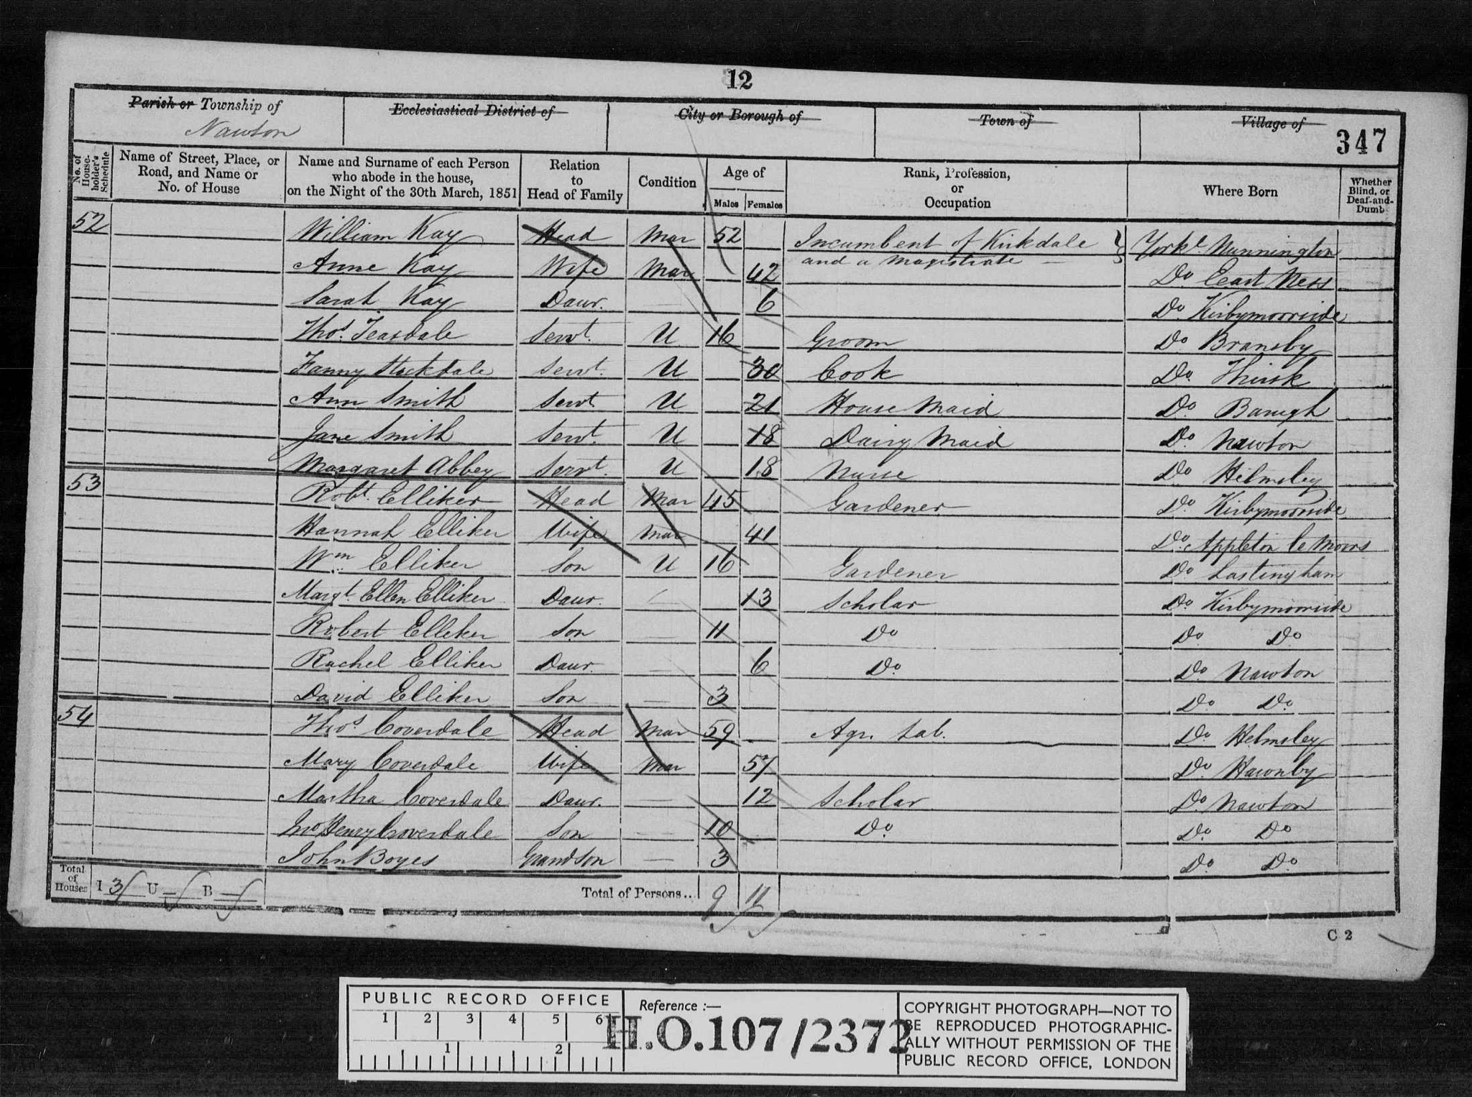
1851 England, Wales & Scotland, Helmsley, Yorkshire & Yorkshire (North Riding.) Sarah Kay is the only child of William and Anne Kay. Source https://www.findmypast.co.uk/transcript?id=GBC/1851/0015646759&expand=true

Figure 2.
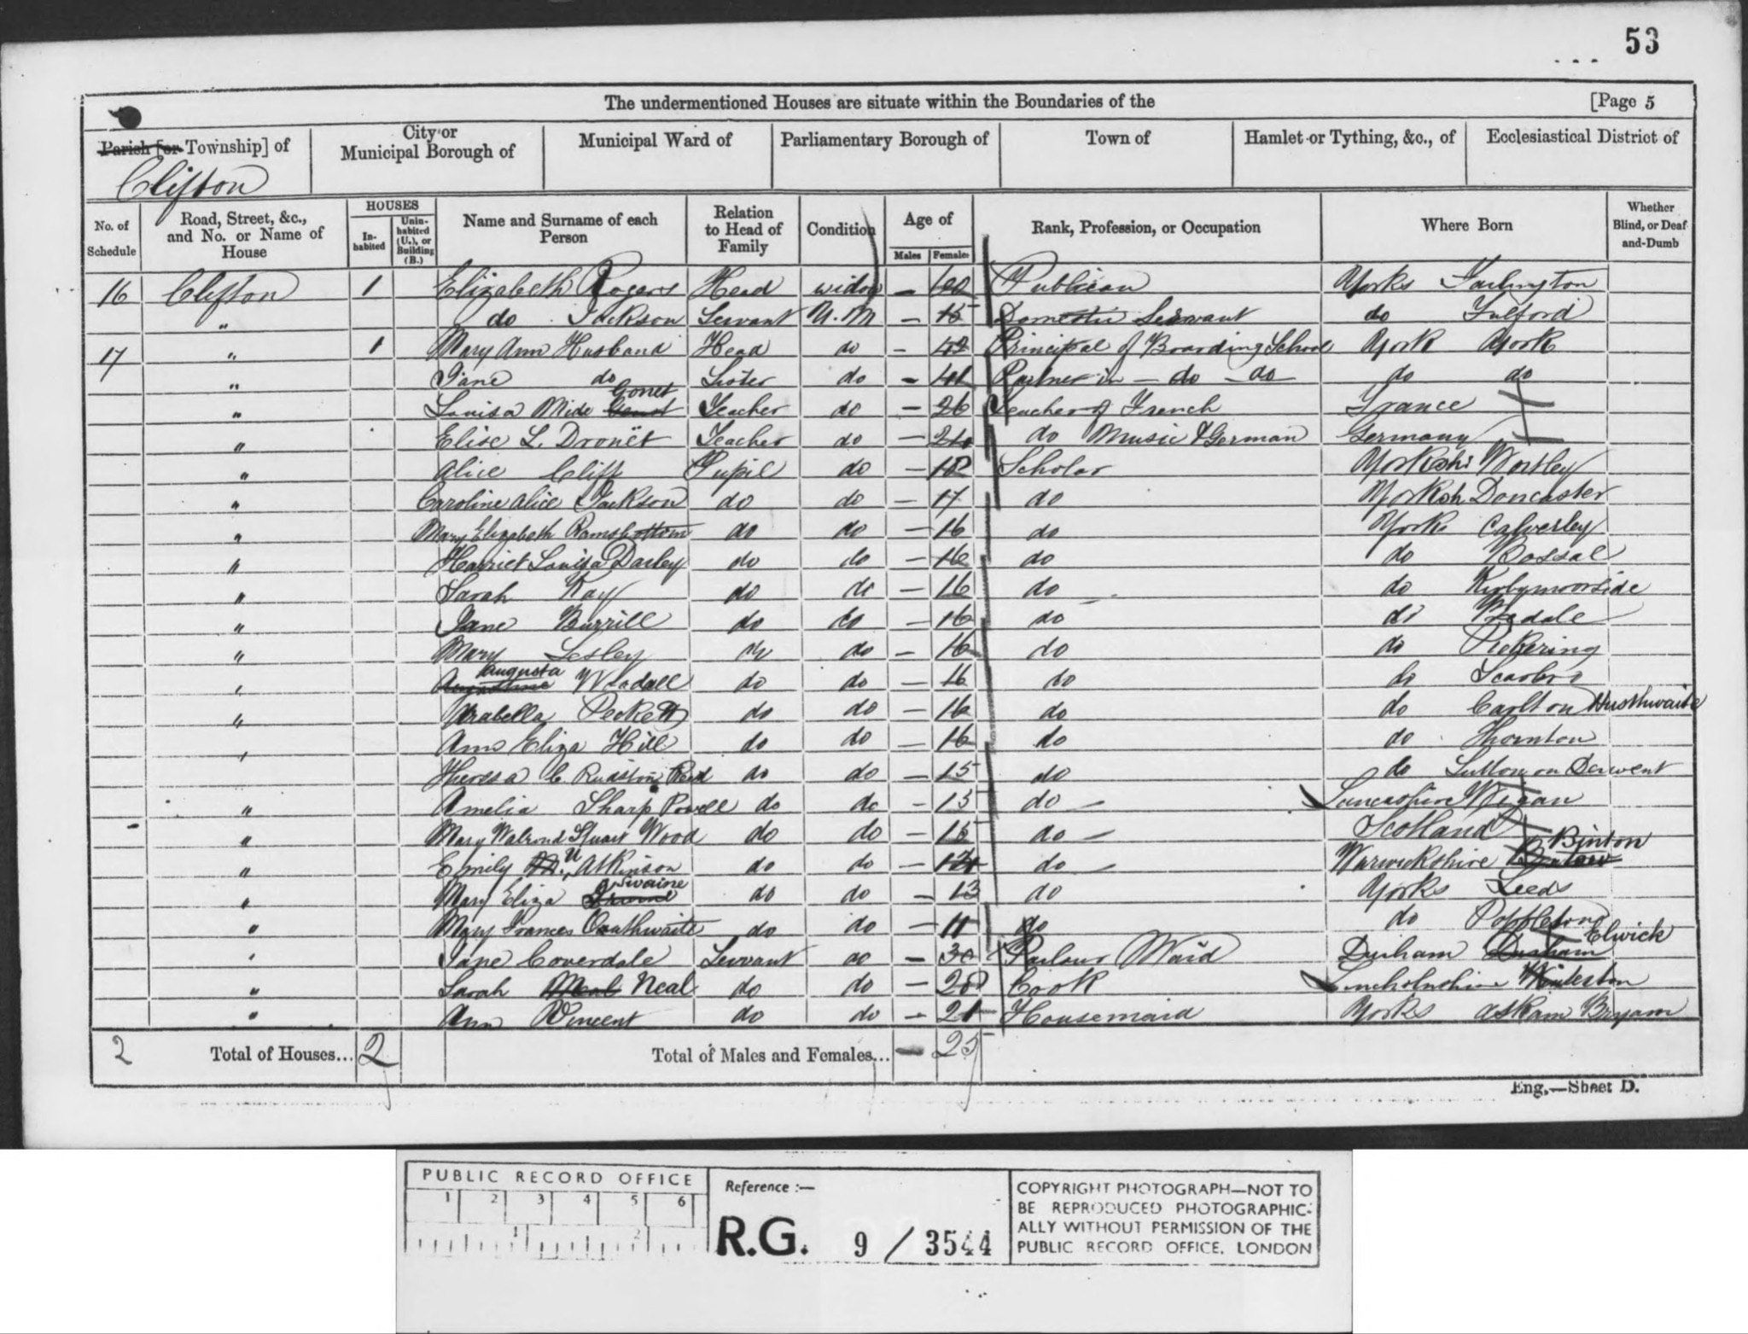
1861 England, Wales & Scotland Census. Clifton, York, Yorkshire. Sarah Kay is listed as a student at a boarding school. Source: https://www.findmypast.co.uk/transcript?id=GBC/1861/0018333265&expand=true.
Figure 3.
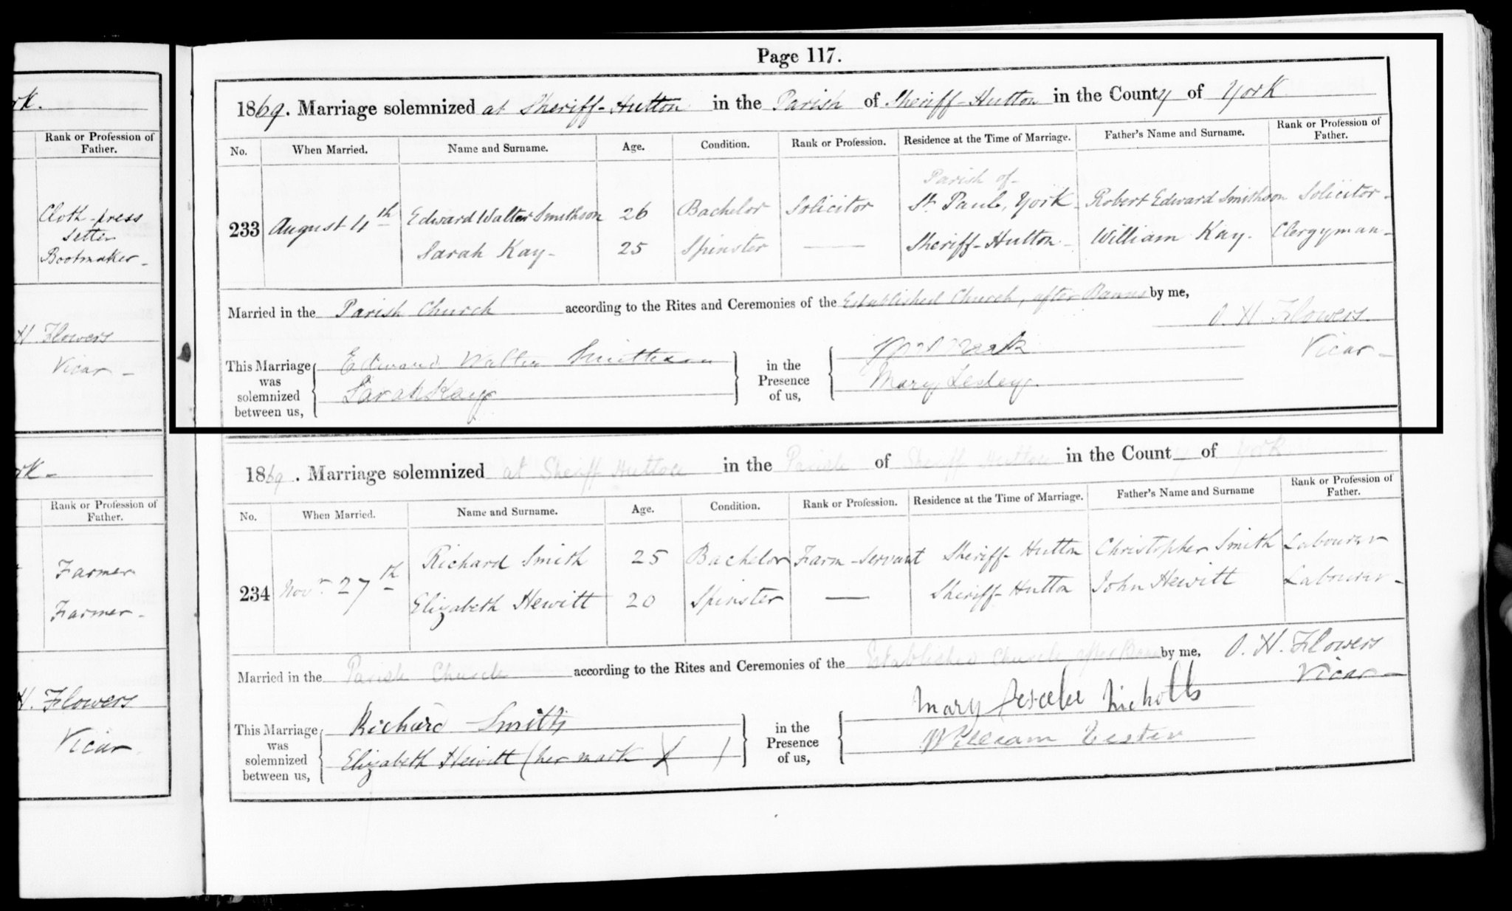
A copy of the marriage certificate of Edward and Sarah Smithson, from Yorkshire Marriages Records, who married August 4th 1869 in Sheriff Hutton Church, Yorkshire. Source https://www.findmypast.co.uk/transcript?id=GBPRS%2FYORKSHIRE%2FMAR%2F301437224%2F1

Figure 4.
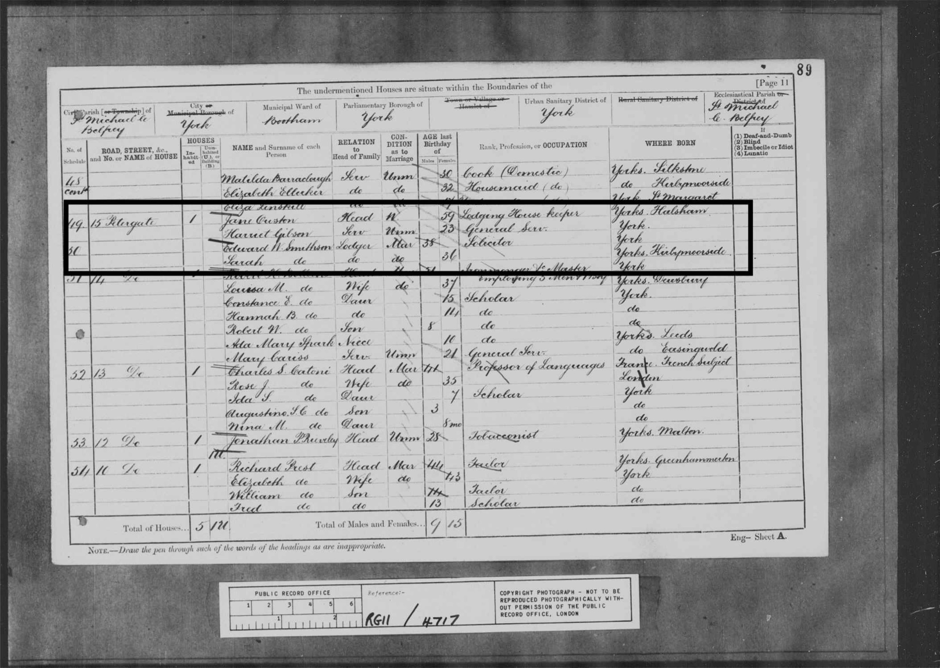
1881 England, Wales & Scotland Census. Sarah and Edward live as lodgers in Petergate, York. Source https://www.findmypast.co.uk/transcript?id=GBC%2F1881%2F0022073544

Figure 5.
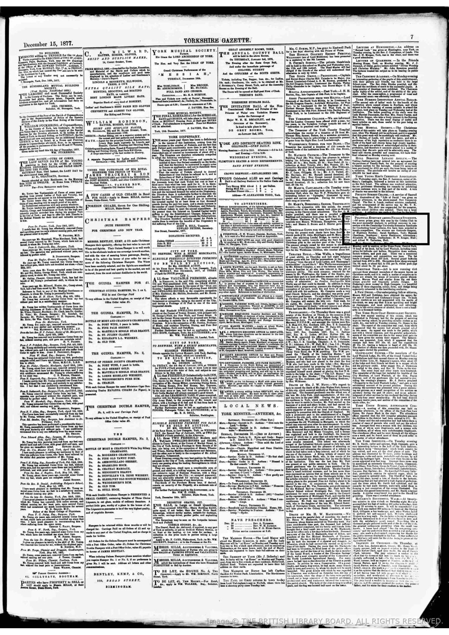
Yorkshire Gazette article 15th December 1877 detailing the Political Economy Prize awarded by the Cobden Club to Sarah Smithson. Source British Newspaper Archive, https://search.findmypast.co.uk/bna/viewarticle?id=bl%2f0000266%2f18771215%2f141&stringtohighlight=sarah%20smithson
Figure 6.
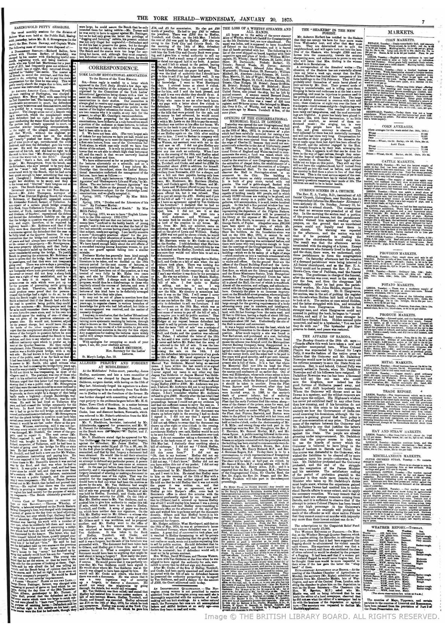
York Herald 20th January 1875. Sarah Smithson writes to the editor of the York Herald and is titled “The secretary of Ladies’ Lectures.” Source https://search.findmypast.co.uk/bna/viewarticle?id=bl%2f0000499%2f18750120%2f032&stringtohighlight=sarah%20smithson

Figure 7.
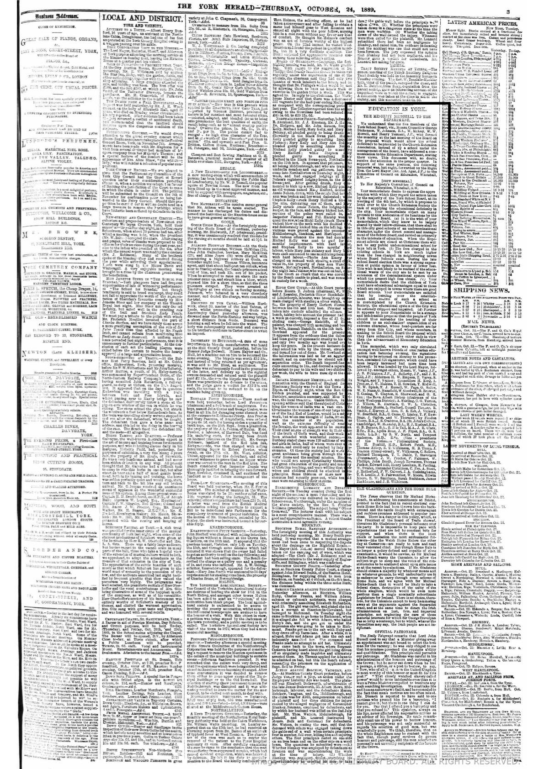
York Herald 24th October 1889. There is detailed a “memorial” signed by local “well-known friends of unsectarian education” regarding the role of the church in schooling. Sarah Smithson’s name appears alongside Joseph Rowntree’s. Source https://search.findmypast.co.uk/bna/viewarticle?id=bl%2f0000499%2f18891024%2f005&stringtohighlight=sarah%20smithson
Figure 8.
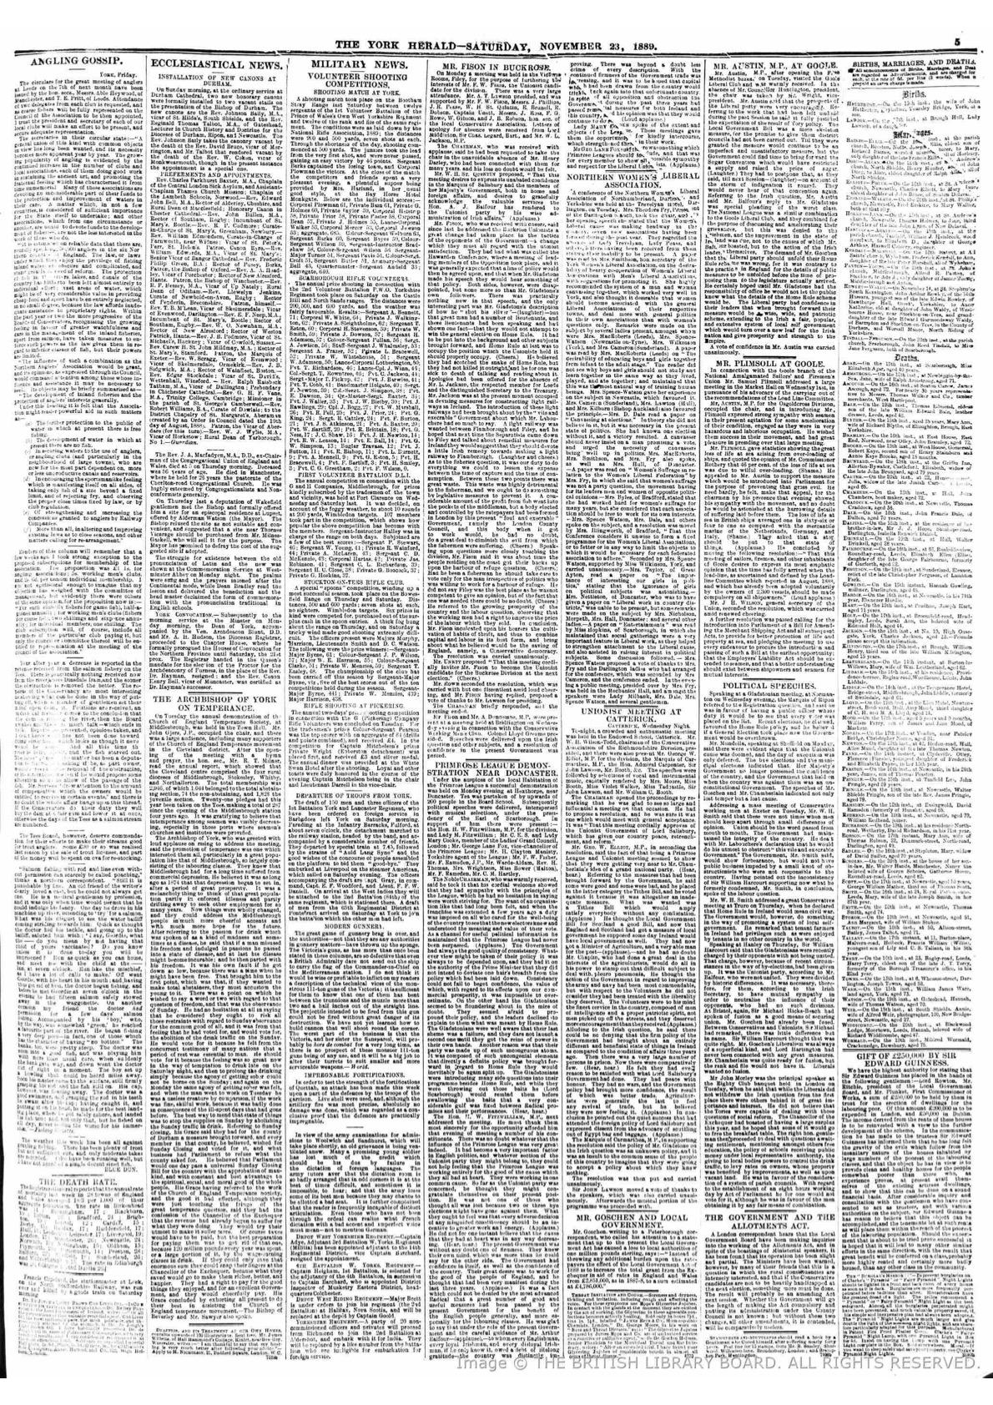
The York Herald 23rd November 1889, it is reported that Smithson travelled to Darlington to speak at the Northern Women’s Liberal Associations Conference. Source https://search.findmypast.co.uk/bna/viewarticle?id=bl%2f0000499%2f18891123%2f094&stringtohighlight=northern%20womens%20liberal%20association
Figure 9.
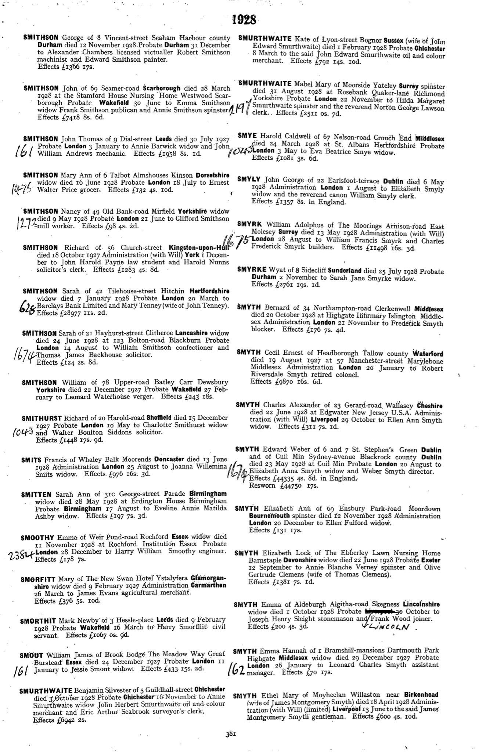
England & Wales Government Probate Death Index 1858- 2019, lists the details of Sarah Smithson’s will, where she died and when. Source https://www.findmypast.co.uk/transcript?id=GBOR%2FGOVPROBATE%2FC%2F1928-1928%2F00087174

She was the only child of William of Sarah Kay, her father on various official documents has been listed as a magistrate, a clergyman and an “incumbent of Kirkdale,” a vale of Yorkshire. Her mother appears never to have been employed which is also indicative of the family’s social standing.
We may assume this to be the Mount School, or a former actualisation of the now St. Peter’s School.
We are not sure of where they lived once they were married however we could assume they moved into the city of york away from Sarah’s more rural upbringing.
It is unclear if Sarah had any formal higher education however she was highly capable and was also an advocate for girls in higher education which may suggest she benefited from it.
The couple have 3 female servants, a cook, a parlourmaid, and a housemaid, indication of their wealth. There is still no evidence the couple have any children. 1894 03 March, York Herald report of a York Women’s Liberal Association whereby the “Question of Women’s Suffrage” was addressed. This demonstrates the longevity of Smithson’s dedication to the cause which lasted throughout her adult life.
This is a final testimony to the social standing maintained by Sarah throughout her life and perpetuated by the couple together.
Elizabeth Crawford, “The Women’s Suffrage Movement in Britain and Ireland: A Regional Survey.” (London: Routledge, 2013).
Elizabeth Crawford, “The Women’s Suffrage Movement in Britain and Ireland: A Regional Survey.” (London: Routledge, 2013).
Ibid.

